AN ARTIFICIAL BEACH AS A MEANS FOR SEA COAST PROTECTION FROM STORM SURGES (BY THE EXAMPLE OF THE EASTERN GULF OF FINLAND)

Leont’yev, I.O., Akivis, T.M. (P.P. Shirshov Institute of Oceanology RAS, Moscow)

A model of an artificial beach is suggested for protection of coasts under erosion due to intense storm surges. It is shown that the coarser beach sand results in decrease of the beach width and growth of nourishment volume. At the same time relative material loss due to long-shore sediment transport diminishes too. The model has been applied to three sections of the coasts of Kurortny district of S.-Petersburg (eastern part of the Gulf of Finland). It recommends medium sand for the beaches construction. Modeling of extreme storms effect shows only minor deformations for designed beach profiles. For the beaches more than 1 km long even in 30-50 years more than a half of the initial beach volume conserves without additional nourishment.
Key words: sand coast, artificial beach, beach profile, sediment flux, Gulf of Finland.

INTRODUCTION
Artificial beaches are widely applicable in the coastal protection practice for minimizing storm effect [1], [2]. Actual Russian recommendations for calculation of beach profiles [3] are related to coasts with no sea level changes. But there are a lot of coasts with dynamics governed by high storm surges. One of the examples is the coast of Kurortny district of S.-Petersburg in the eastern part of the Gulf of Finland (Fig. 1) which undergoes significant erosion [4], [5].

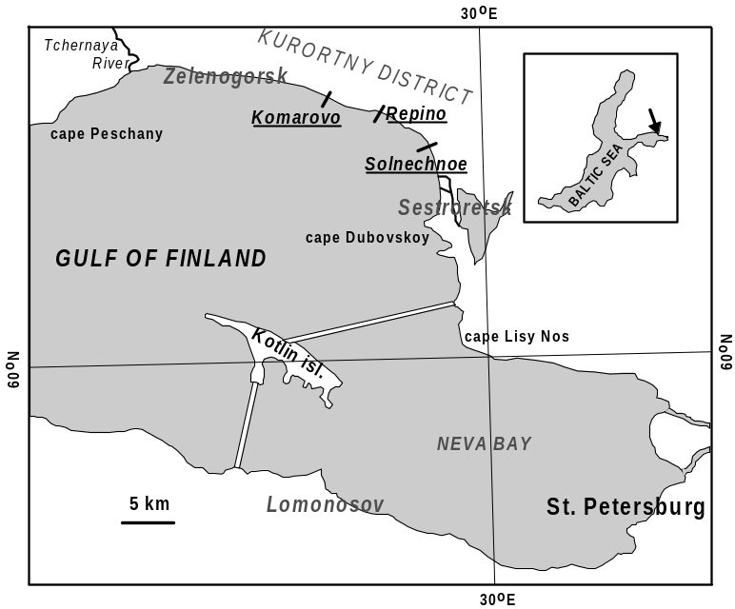

Fig. 1. The coast of the eastern Gulf of Finland and location of designed profiles Komarovo, Repino and Solnechnoe.

The actual situation could be improved by construction of artificial sand beaches at vulnerable segments of the coast. But, for the surges higher than wave height, prediction of stable beach parameters is hardly possible on a base of traditional methods. In this paper a model of a stable beach is suggested and applied to three segments of the Kurortny district coast (Fig. 1). Effectiveness of the modeled beaches verified by means of mathematical modeling of the extreme storm action on the coast.

A MODEL OF A STABLE BEACH
Profile geometry. A scheme of profiles of natural and designed beaches is given in Fig. 2. An elevation z is measured from the lower still water level and horizontal distance x is counted off seaward from the highest beach point which is the sum of the storm surge η and wave run-up R heights.
A horizontal segment l_{a} corresponds to the berm width. Its variations allow displacement of the whole designed profile seaward or landward in order to achieve its intersection with the natural profile in the closure depth 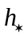. The latter bounds the area of significant sea bed deformations.

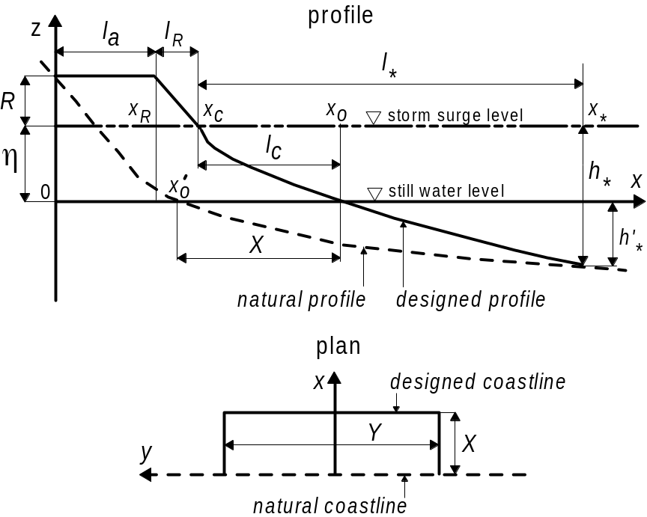

Fig. 2. A scheme of an artificial beach. The notations are in the text.

The distance 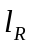 is a width of a wave run-up zone dependent of its height R and beach slope 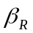:
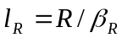. (1)
A segment corresponding to underwater part of designed profile under storm surge conditions is defined by Dean’s equilibrium profile [1], [6], [7]:
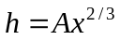, 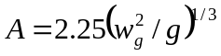, (2)
where h – is water depth relative to the storm surge level, 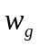 – grain settling velocity in water, g – acceleration due to gravity. Parameter A is of order of 10⁻¹ m^{1/3} and increases as the grain size grows. So a length of the segment is 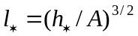.
Total width of the artificial beach above the still water level is 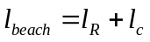, where 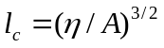 is a distance between the coastline positions for storm and still conditions (points 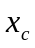 and 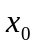 in Fig. 2).
A difference between coastline positions of designed and natural profiles, 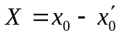, defines the advance of the coastline within the artificial beach.
The elevations of the designed profile are expressed by the following relationships:
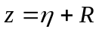, 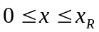,
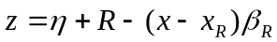, 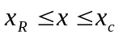, (3)
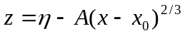, 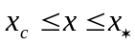.
Location of the points 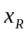, and 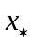 is explained in Fig. 2.
A volume of the material V per unit length of the coastline (m³ m⁻¹) required for the beach construction can be found as
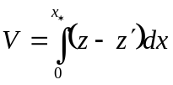, (4)
where 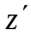 is an elevation of the natural profile relative to the still level.

Design equations. The designed beach is rated for extremal storm with significant wave height in the open sea 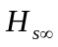, spectral peak period 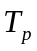 and maximal storm surge level .
A height of wave run-up is estimated by known Hunt formula [8], [9]
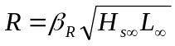, (5)
where 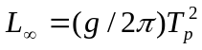 is deep water wavelength. It follows from Eqs. (5) and (1) that the run-up zone width depends only on the wave parameters: 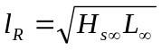.
An equilibrium bed slope in the run-up zone 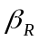 is calculated on a base of a Sunamura formula [10], used in [3] too:
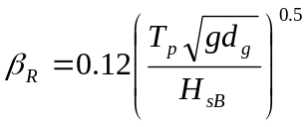. (6)
Here 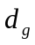 is average sand grain size, 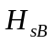 is significant wave height at the wave breaking depth 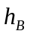. The latter is interpreted as the depth of breaking of waves of 1% cumulative exceedance in the wave ensemble. If the direction of wave propagation is perpendicular to the coastline we have [11]
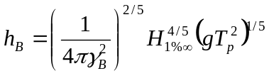, (7)
where 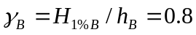 is the breaker index. In a case of Rayleigh wave heights distribution, 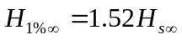 and 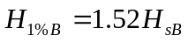, whence 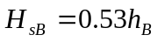.
And, at last, the depth of wave breaking and the closure depth are assumed equivalent:
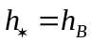. (8)

ARTIFICIAL BEACHES FOR THE KURORTNY DISTRICT OF SANKT-PETERSBURG
Basic assumptions. The model has been applied for design of artificial beaches capable of coasts protection in Kurortny district of Sankt-Petersburg within Komarovo, Repino and Solnechnoe segments (Fig. 1), where sand beaches are relatively narrow and dunes are low.

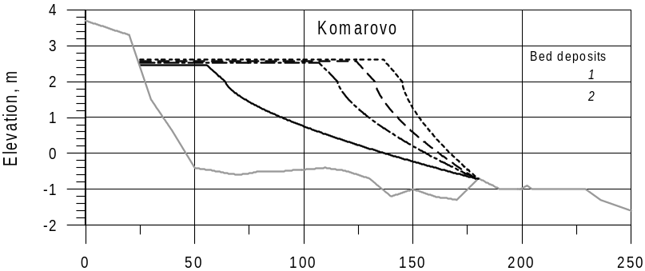
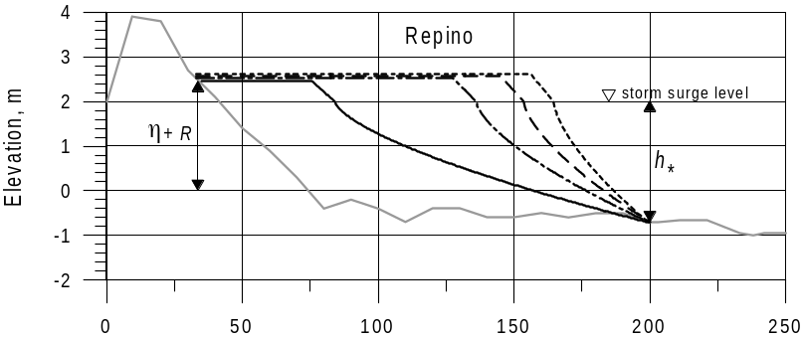
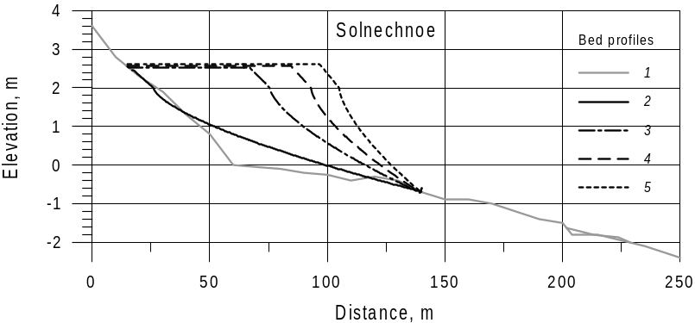
Fig. 3. Initial sea bed profiles, bed sediment characteristics and designed beach profiles for three coastal segments of Kurortny district. Bed sediment: 1 – sand, 2 – cobble. Sea bed profiles: 1 – initial, 2, 3, 4 and 5 – artificial profiles constructed from the sand of grain size 0.3, 0.5, 0.7 and 1.0 mm respectively.

Typical sea bed profiles and bed sediment properties are represented in Fig. 3. They are based on monitoring data of the coastal zone collected for a number of years by A.P.Karpinsky Russian Geological Research Institute (VSEGEI) in Saint-Petersburg [12]. The storms accompanied by the surge of about 2 m height inflict the most valuable damage for the coasts. This kind of storms occurred approximately once every 25 years [13] but in the last decades their frequency at least doubled [5]. Parameters of the extreme event peak are the following [4]:
=1.6 m, =5.4 s, =2.0 m.
The closure depth according to (7) and (8) is =2.7 m, so the depth of the profile base relative to the still level is 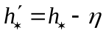=0.7 m (Fig. 2).
Results of calculations. The artificial beaches were designed on a base of parameters given above for four different sand grain sizes: 0.3, 0.5, 0.7 and 1.0 mm. The profiles obtained are shown in Fig. 3 and their parameters are given in Table 1. It can bee seen that the maximal profile elevation is η+R is equal 2.5–2.6 m.

Table 1. The designed parameters of artificial beach profiles for different sand grain size

,  mm | 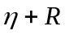,  m | 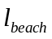,  m | Komarovo |  |  | Repino |  |  | Solnechnoe
 |  |  | ,  m | ,  m | V,  m³/m | ,  m | ,  m | V,  m³/m | ,  m | ,  m | V,  m³/m
0.3 | 2.46 | 82 | 93 | 31 | 210 | 85 | 42 | 175 | 40 | 0 | 31
0.5 | 2.53 | 49 | 110 | 83 | 322 | 101 | 95 | 289 | 56 | 52 | 131
0.7 | 2.57 | 38 | 119 | 100 | 364 | 108 | 113 | 332 | 63 | 70 | 171
1.0 | 2.62 | 31 | 125 | 113 | 398 | 112 | 125 | 363 | 68 | 83 | 202

The beach width reduces for the coarser sand: from 82 to 31 m for 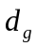 growth from 0.3 to 1 mm. On the contrary, the berm width and the coastline propagation X increase with sand grain size. The beach volume V is more dependent on and also grows with the material grain size.
So the use of the coarser sand needs the greater nourishment volume and increases the cost of the project. For the Komarovo and Repino sites sand of 0.3 mm is the most economical and provides the maximal beach width. For the Solnechnoe beach there is no berm material reserve (=0) and the coarser sand, say, 0.5 mm, should be used here.

BEACH STABILITY TEST

The test of the beach stability was carried out by mathematical modeling of storm effects on beaches using the model CROSS-P which was applied earlier to the same coasts [4].
The parameters of the extreme storm peak for computation of artificial beaches were given above. The typical scenario of a similar storm is described in [4]. The storm duration is about 24 hours. On the stage of development the level and wave parameters are growing but after the peak passes all the parameters reduce. Angles of wave approach relative to the normal to the coastline can be taken as 45º for Komarovo and Repino and 15º for Solnechnoe.
The beach profiles constructed from 0.3 and 0.5 mm sand where taken as initial. The modeling results are shown in Fig. 4.
It can bee seen that the storm action results in relatively minor variations of the profile morphology. Maximal deformations don’t exceed 0.5 m. Slight erosion of the upper part of the beach and some sediment transport downward the slope don’t lead to appreciable material loss. In comparison, the same storm effect on natural (unprotected) beach can cause several meters retreat of the front foredune slope [12], [4]. Apparently, the beaches designed can withstand more than one severe storm attack and their lifetime is evidently longer than the return period of extreme storms (of order 10 years).

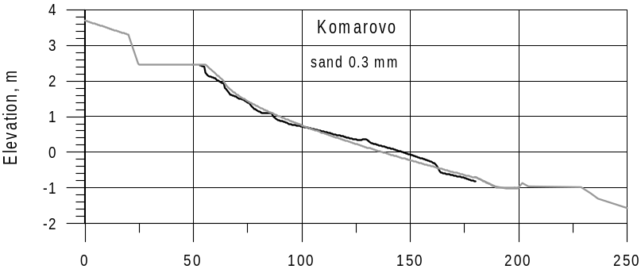
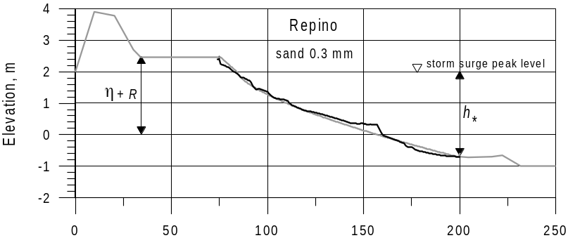
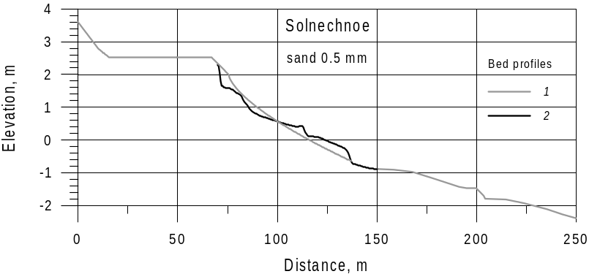
Fig 4. Modeled artificial beaches deformations: 1 – initial seabed profile, 2 – the profile after extreme storm.

Notice that the results favor the correct choice of the closure depth 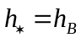because deeper deformations are practically negligible.

BEACH MATERIAL LOSS
Plane view of the artificial beach looks like a distribution of the coastal line in a rectangular form of cross-shore width X and along-shore length Y (Fig. 2). Affected by alongshore sediment transport the beach volume will decrease with time and the beach plane view will change. The processes can be described by the mass conservation law [1] which, under certain conditions, takes a form of diffusion equation:
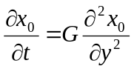, 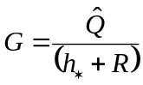, (9)
where is the coastline location, t is time, y is alongshore distance, and parameter G plays a role of diffusion coefficient (m²/year). It can be shown that the value 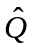 expresses the doubled maximal capacity of the alongshore sediment flux 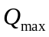 (m³/year).

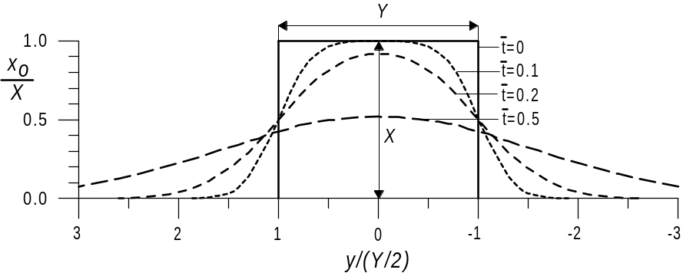
Fig. 5. Evolution of the artificial beach coastline. The non-dimensional time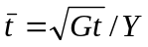.

Fig. 5 represents the solution of equation (9) obtained by Dean. Alongshore fluxes are assumed symmetrical. It is seen that the beach body spreads gradually due to alongshore sediment transport towards both sides. In case of dominant flux to one of the directions the beach view would be non-symmetrical.
According to Dean’s results the material volume V(t) within the beach boundaries in relation to initial volume V0 can be estimated by approximate formula
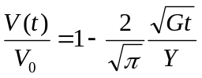. (10)
A coefficient G can be found by evaluation of potential sediment fluxes at artificial beaches in the Gulf of Finland region. Calculations were carried out on a base of Leont’yev’s method [11], [14] for different sand grain sizes and wave data from [15]. The results show that a scale for maximal sediment flux capacity 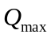 can be taken as 10×10³ m³/year for medium sand (0.3 mm) and 5×10³ m³/year for coarse sand (1.0 mm). Taking into account 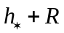 ≈ 3.2 m corresponding diffusion coefficients are G_{0.3} ≈ 6×10³ m²/year и G_{1.0} ≈ 3×10³ m²/year.
The graphs of the relationship (10) for medium and coarse sand and three different beach lengths are shown in Fig 6. As seen, the longer beach and the coarser sand the less relative material loss. For coarse sand a beach of length 250 m loses a half of its volume in 4 years. For a beach of 500 m it takes 16 years and for the beach length 1000 m more than a half of the initial volume remains even after 50 years. For the medium sand the material loss increases and 1000 m long beach decreases by half in volume after 32 years. This value can be considered quite reasonable because minor periodical sand nourishment is enough for keeping satisfactory beach condition.

CONCLUSIONS
The suggested model of artificial beach takes into account particularity of beaches under significant storm surges effect. The highest beach profile elevation corresponds to the maximal surge under rare (10 years) extreme storm and the lowest level corresponds to the wave breaking depth for the maximal water level. The profile features are considered on a base of Dean equilibrium profile concept [6], [7] using empirical results [10].

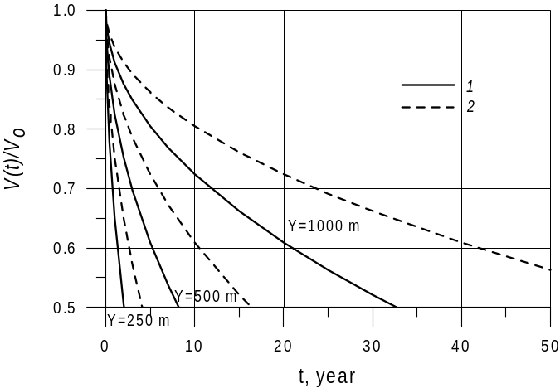
Fig 6. Decrease of artificial beach volume with time for different beach length (Y) and sand grain size: 1 – medium sand 0.3 mm, 2 – coarse 1.0 mm.

Increase in a beach sand size results in decrease of the beach width, wider berm and growth of nourishment volume. The beach length growth leads to increase of the project costs. These tendencies should be considered together with potential material loss caused by alongshore sediment transport outward the beach borders.
The method of beach design described in the article was applied to three sites of eroded coast of the Kurortny District of S.-Petersburg. To meet the demand of decrease of nourishment material volume and construction of wide enough beaches the medium sand (0.3–0.5 mm) can be recommended. In this case the width of the above-water part of the beach will 50-80 m and the nourishment volume will be of order (1.3–3.2)×10² m³ per 1 m of the coastline length depending on sediment deficiency at the site. A propagation of the coastline will comprise 90-100 m at Komarovo-Repino segment and about 60 m in Solnechnoe segment.
A volume of the material loss is estimated in the work using Dean’s approach [Dean, 2002] based on the solution of the coastline evolution equation. One of the key parameters here is the diffusion coefficient G depending on maximal capacity of the alongshore sediment flux. Calculations lead to conclusion that G value for coarse sand (1.0 mm) is half as many as that for medium sand (0.3 mm). This means decrease of relative loss with growth of the material grain size. Another important parameter is the beach length. Its increase also results in loss reduction. Optimal beach length for the conditions under consideration is at least 1 km. In this case more than a half of the beach volume can persist even in 30-50 years (depending on sand grain size) without additional feeding. In the same time a beach of length 250 m will require every year nourishment amount of more than 25% of initial volume.
A stability of the designed beaches is verified by modeling of extreme storm effect. It was revealed that the beach profiles undergo only minor deformations and can keep their resource for a sufficiently long time that exceeds the return period of extreme events.

ACKNOWLEDGEMENT
The work is supported by RSCF (Grant # 14-17-00547).

REFERENCES
1. Dean R.G. 2002. Beach Nourishment: Theory and Practice. World Scientific Inc. 2002. 399 p.
2. Khabidov A.Sh., Leont’yev I.O., Marusin K.V., Shlychkov V.A., Savkin V.M., Kuskovskiy V.C. 2009. Man-made Lake Shore Management. Novosibirsk. Pub. House SB RAS, 2009. 239 p.
3. Set of Rules. 2009. «Design of Sea Protective Constructions». SP 32-103-97. NIC «Sea coasts». TSNIIS. 1997. 141 с.
4. Leont’yev I.O., Ryabchuk D.V., Sergeev A.Yu. 2015. Modeling of Storm-Induced Deformations of a Sandy Coast (Based on the Example of the Eastern Gulf of Finland). Oceanology. 2015. V. 55. № 1. P. 131-141.
5. Leont’yev I.O., Ryabchuk D.V., Sergeev A.Yu., Kovaleva O.A. 2015. The Forecast of Coastal Recession in the Eastern Gulf of Finland for the Twenty-First Century. Oceanology. 2015. V. 55. № 3. P. 434-440.
6. Dean R.G. 1991. Equilibrium Beach Profiles. Characteristics and Applications // J. of Coastal Res. 1991. V. 7. № 1. P. 53–84.
7. Kriebel D.L., Kraus N.C., Larson M. 1991. Engineering Methods for Predicting Beach Profile Response. Int. Conf. “Coastal Sediments’91”. Seattle. 1991. P. 557–571.
8. Hunt I.A. 1959. Design of Seawalls and Breakwaters. J. of Waterway and Harbors Div. 1959. V. 85. P. 123–152.
9. Leont’yev I.O. 2001. Coastal Dynamics: Waves, Currents, Sediment Transport. М.: GEOS, 2001. 272 p.
10. Sunamura T. 1989. Sandy Beach Geomorphology Elucidated by Laboratory Modeling. In: Coastal Modeling: Techniques and Applications. Lakhan V.C., Trenhail A.S. (Eds). Elsevier, Amsterdam. 1989. P. 159-213.
11. Leont’yev I.O. 2014. Morphodynamic Processes in the Coastal Zone of the Sea. Saarbrücken: LAP LAMBERT Academic Publishing. 2014. 251 c. ISBN: 978-3-659-62831-3.
12. Ryabchuk D.V., Kolesov A.M., Sergeev A.Yu. et al. 2012. Abrasion Processes in the Coastal Zone of the Western Gulf of Finland and their Connection with Long-term Tendencies of the Key Regime Factors. Geomorphology, 2012. № 4. P. 99–105.
13. Barkov L.K. 1991. Lithodynamic Processes in the Coastal Zone of the Western Part of the Gulf of Finland from c. Lautaranta to c. Dubrovsky. Proc. RGS. 1991. V. 123. Issue 1. P. 60–67.
14. Leont’yev I.O. 2014. Calculation of Longshore Sediment Transport. Oceanology. 2014. V. 54. № 2. P. 226-232.
15. Leont’yev I.O. 2008. An Estimate of the Cross-shore Sediment Flux at the Boundary of the Coastal Zone. Oceanology 2008. V. 48. № 1. P. 123–126.

